So this way we have created an android game. So now to build it we go to file and then go to build settings Now a window will be opened like below
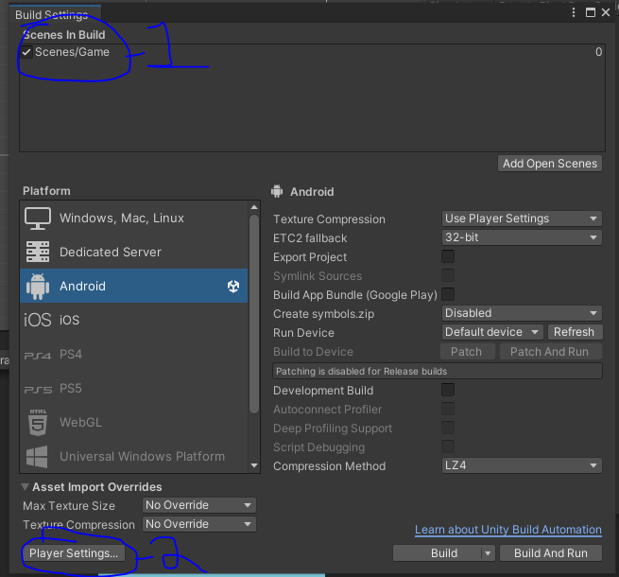
Now as marked 1 make sure scene in which we made our game is added to the list and checked
Now go to Player setting as marked above
Now a new window will be opened like below as marked
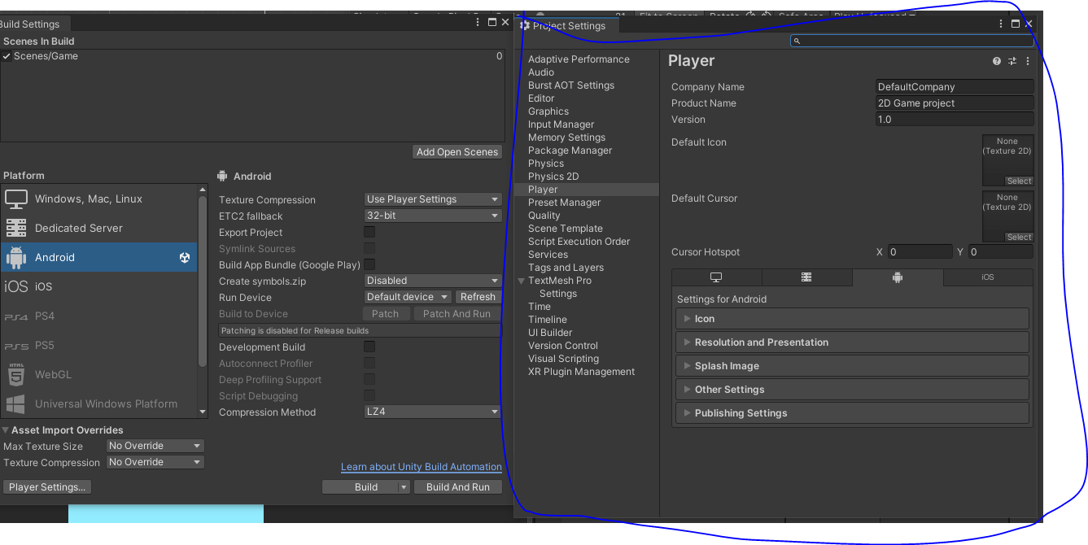
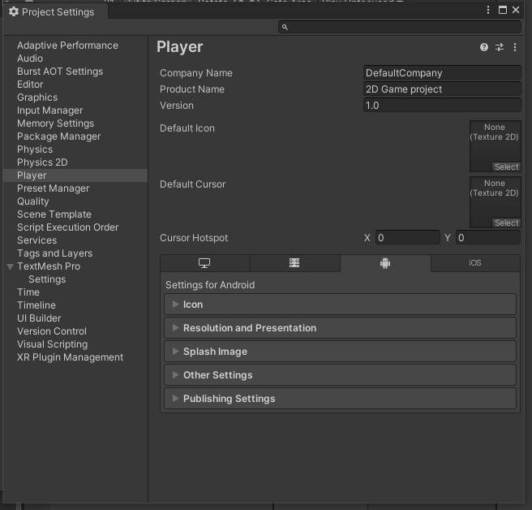
Now in Company name we write the name of the comapany to which the game belong to.
And the Product name we tell the name of the game we have made
In defailt icon we tell the icon of the game we will see in our Android device
we set it to pig image by dragging the image from sprites folder in Project Panel in Unity to that Default icon rectangle
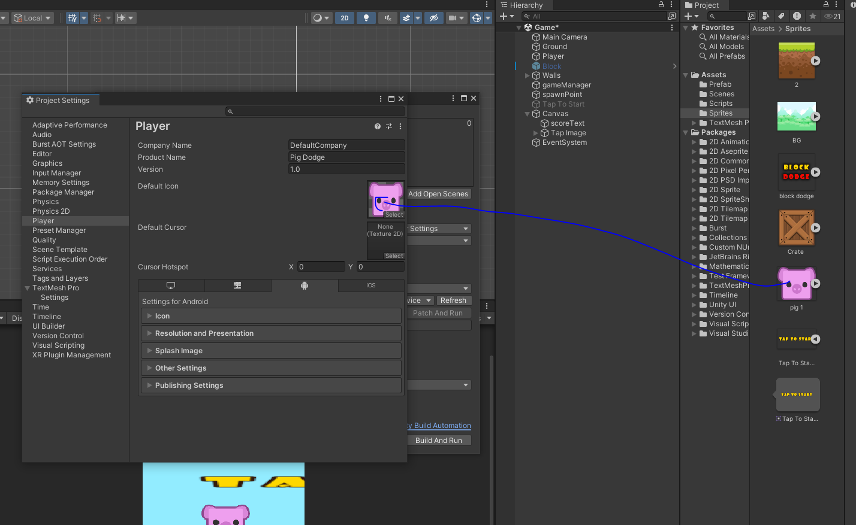
Now we go to other setting ad marked below and then expand it.
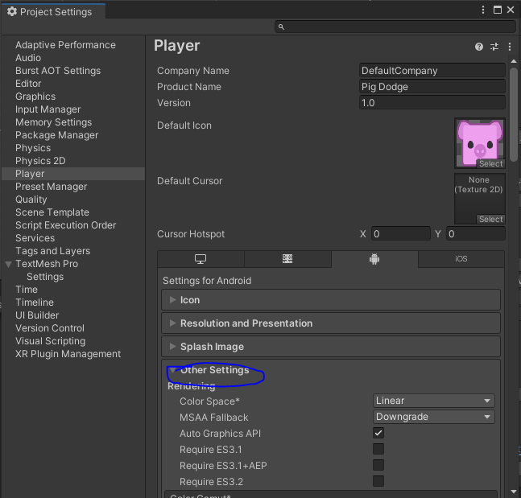
Now go to Identification section and then go to version field as marked below
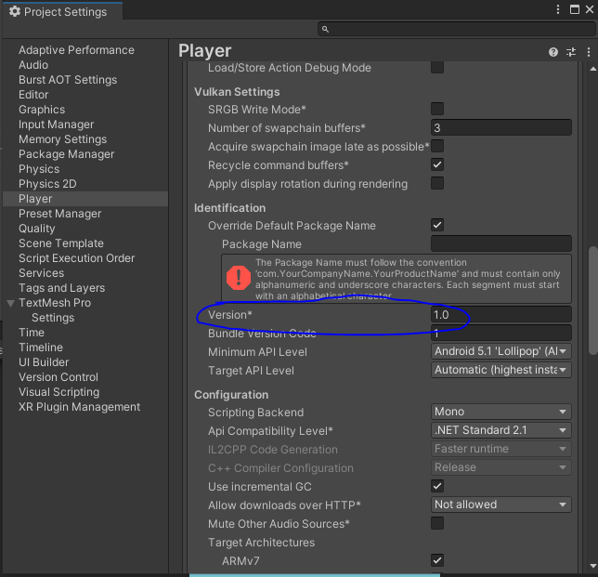
We will give different version for every new version of the game build
In minimim API level and target API level we select the target architecture and you can select the version of the android
The package name is very essential otherwise you cannot export it Now if you uncheck the Override Default package name then the unity will give its own package name

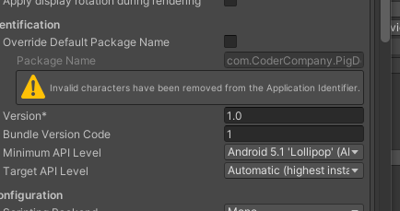
So Now our package name is com.CoderCompant.PigDodge
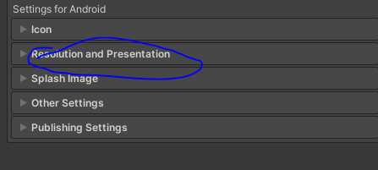
Now we will expand the Resolution and Presentation
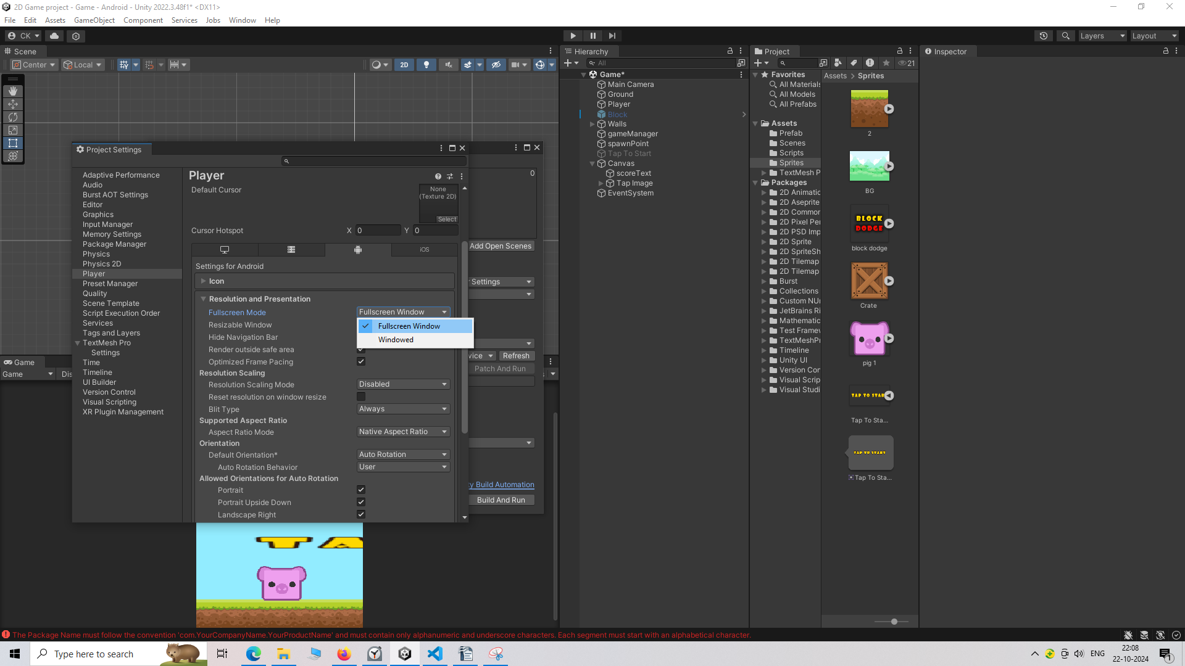
and now in Fullscreen mode you choose whether your game will be windowed means ther will be upper menu of evetry typical app
and in Full screen window mode the game will cover teh whole screen
We choose the full screen
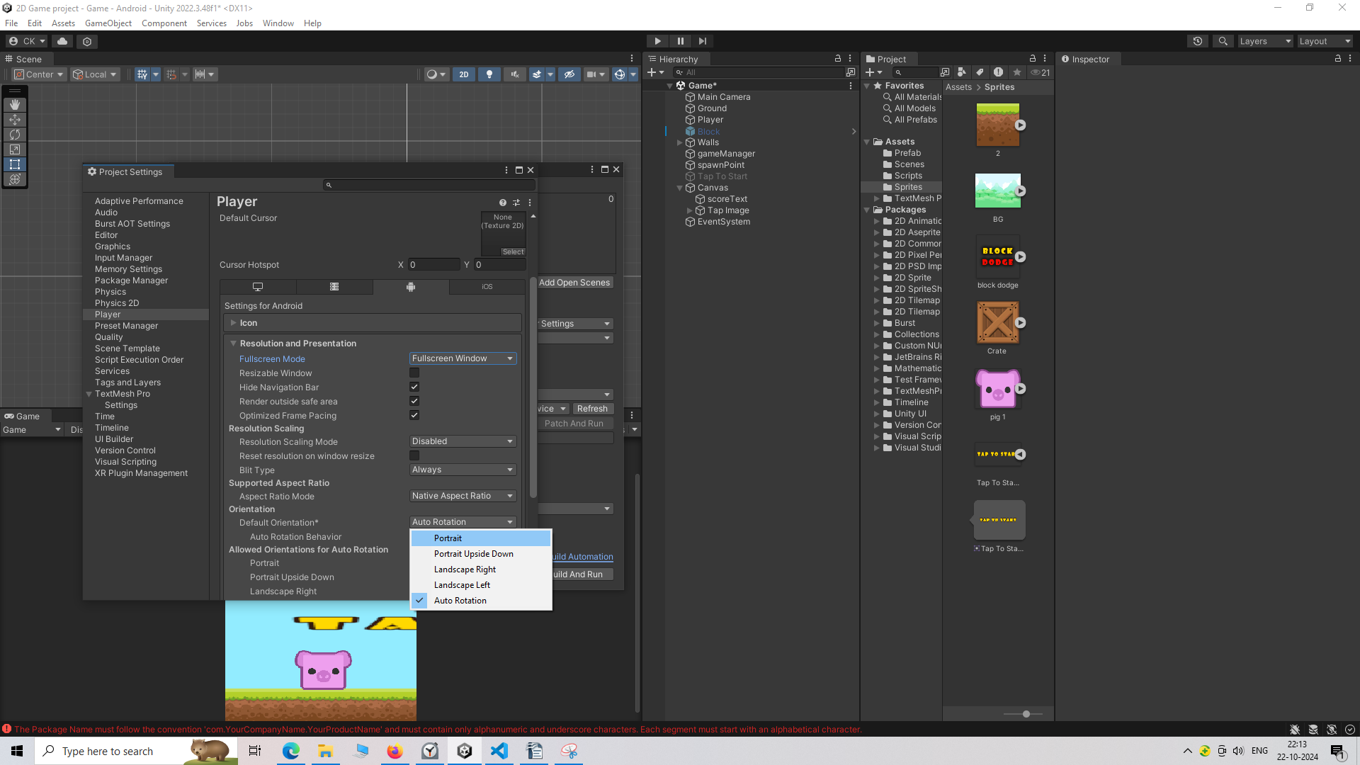
Now in Default orientation choose Portrait instead of Auto Rotation as we want to play this game in Portrait only
Now with this done our game is now ready to be build
Now we will close the Project Settings or Player settings
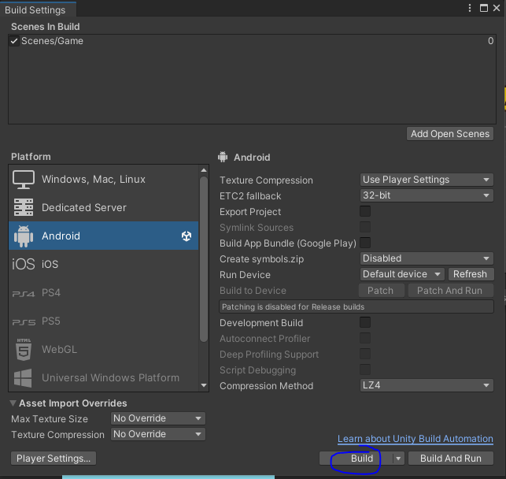
Now in Build Settings window click on the Build button as marked above
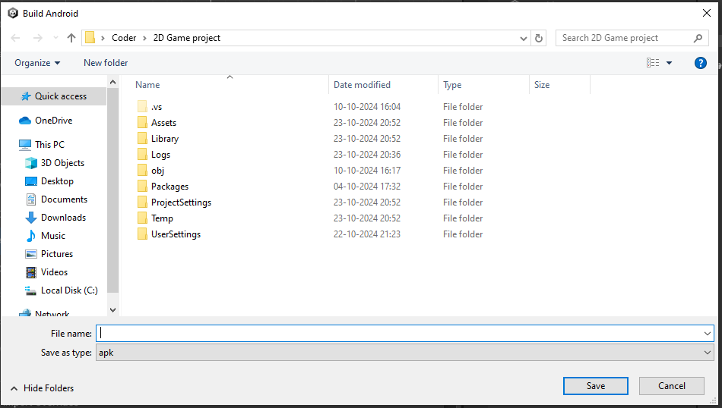
Now a window will look like above
Here we will create a new folder Android Build Folder and then we go inside it. And we name the File Pig Dodge then click on Save button to make the apk file here.
If the project is not saved then it will prompt you to save and then show you loading window as shown below
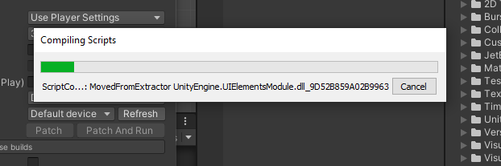
if there is any error in your script then the game may not build in my case i was using a class or maybe file not present in our library so commented its declaration.
As shown below
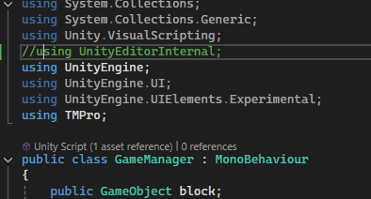
So this way we created our game or installed and play in mobile.

